FLOORPANEL

Technical Data Sheet

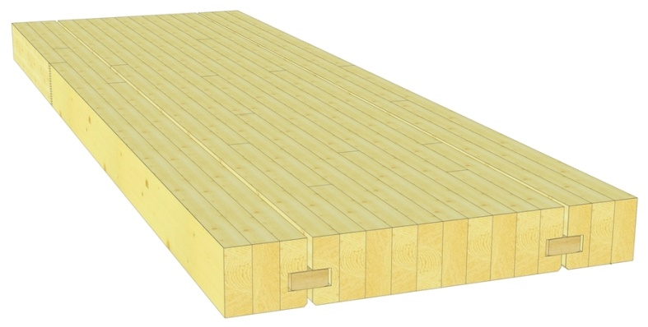

Wood type: | Spruce/fir  Others on request
Quality: | N: Normal; for visible applications  I: Industrial; for constructions with lower aesthetic requirements
Strength class: | C24
Panel thickness: | 100 to 260 mm  Others on request
Panel width: | 150 to 1000 mm  All widths within this range are possible. Billed per 50 mm increments.  Others on request
Length: | According to list
Laminate widths: | Indefinite, 40 to 70 mm
Surface: | All sides planed and chamfered; for visible applications, sanding the surface is recommended (not standard)
Profile: | Tongue–tongue profile is standard  Others on request
Specific weight: | 5.0 kN/m³ (according to SIA 261)
Moisture content: | 12% ± 2%
C24 Mechanical Properties: | Bending strength | f_{md} | = 14.0 N/mm²
SIA 265, η_{w}= 1.0, η_{t}= 1.0 | Shear strength | f_{vd} | = 1.5 N/mm²
 | Modulus of Elasticity | E_{m,mean} | = 11.0 kN/mm²
Physical properties: | Thermal conductivity | λ | = 0.13 W/mK
 | Specific heat | c | = 2.0 - 2.4 kJ/kgK
 | Water vapour permeability | δ | = 0.035 - 0.015 mg/mhPa
 | Diffusion Resistance Factor | μ | = 20 - 40
Reaction to fire: | 4.3 (D-s2, d0 according to European Standards)
Gluing: | Polyurethane (PUR) Type I adhesive per EN 15425  Solvent-free (no formaldehyde)  Colourless glue lines

