SLP SINGLE-LAYER-PANEL

Technical Data Sheet

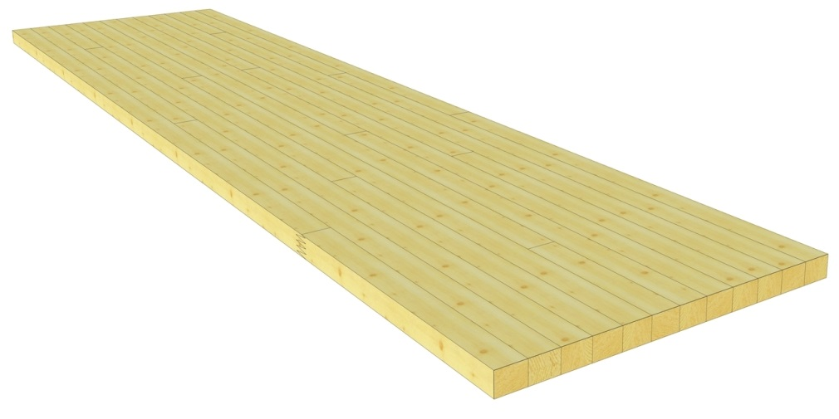

Wood type: | Spruce/fir  Others on request
Quality:  (for a detailed description of quality  see page 3.9) | B/B for applications with both sides visible/exposed  B/C for applications with one side visible/exposed  C/C for non-exposed/visible applications
Strength class: | -
Panel thickness: | 20 to 80 mm  Others on request
Panel width: | 150 to 1000 mm  All widths within this range are possible. Billed per 50 mm increments.  Others on request
Length: | According to list, up to 14.00 m
Laminate widths: | Indefinite, 40 to 70 mm
Surface: | Planed on all sides; bevelling is possible; for visible applications, sanding the surface is recommended (not standard)
Profile: | Profiles are possible by arrangement
Specific weight: | 5.0 kN/m³ (according to SIA 261)
Moisture content: | 12% ± 2%
Physical properties: | Thermal conductivity | λ | = 0.13 W/mK
 | Specific heat | c | = 2.0 - 2.4 kJ/kgK
 | Water vapour permeability | δ | = 0.035 - 0.015 mg/mhPa
 | Diffusion Resistance Factor | μ | = 20 - 40
Reaction to fire: | 4.3 (D-s2, d0 according to European Standards)
Gluing: | Polyurethane (PUR) Type I adhesive per EN 15425  Solvent-free (no formaldehyde)  Colourless glue lines

